Contents
1. Commonly-used terms 2
2. Launching the app 3
3. Opening a solution file (.SLN) 5
4. Viewing a report file (.RDL) 8
4.1. Open the .RDL 8
4.2. The Design pane 9
4.3. The Preview pane 10
4.4. The Report Data pane 12
5. Viewing a shared dataset (.RSD) 16
6. Viewing a shared data source 17
6.1. Open the data source 17
6.2. View the connection credentials 17

Knowledge Article: not yet written
Additional guidance: How to manage reports on the HR Reporting servers
Additional guidance: How to create and amend reports in Visual Studio - pending
Additional guidance: How to manage parameters within Visual Studio - pending

This document provides information that you will need when working in Visual Studio. This is not a process document so much as a “contextual information” document.

Commonly-used terms
There are a number of commonly-used terms that appear throughout this document. A brief explanation of each is given here.

Term | Notes | Example
Dataset | A dataset is the SQL code which queries the PeopleXD database and returns results. It can be embedded (unique to a single .RDL file) or shared (available to re-use across multiple .RDL files). | “DataSet1” within any .RDL file contains the report SQL code.
Dataset (Embedded) | An embedded dataset is a SQL query which is unique to a single .RDL file. | All report queries are “embedded” datasets.
Dataset (Shared) | Shared datasets are SQL queries which are available to re-use across multiple .RDL files. We use shared datasets to return Lists of Values (LOVs) which power parameter drop-down lists. | LOV_Optional_DepartmentCode
Data source | A data source is a connection to a PeopleXD database (UOXC, UOXP, etc.). | Oracle_DS_UserCredentials
Deployment | The act of publishing a report (.RDL file) or a shared dataset to one of the HR Reporting environments.
Design pane | The area of Visual Studio where you render the .RDL file.
Project | A project is a “sub-container” within a solution. The project is where your data sources, datasets, and reports are saved. A solution can contain multiple projects, but for HR Reporting, we have a strict 1-to-1 relationship between solutions and projects, such that each solution only contains a single project. | HR Reporting QA.sln contains project “HR Reporting QA”, which holds the data sources, shared datasets, and reports for the HR Reporting QA environment.
.RDL file | An .RDL file is a report; the terms are interchangeable. | PERDEP01 Full Data Set.RDL
Report | A report within Visual Studio is an individual .RDL file. | PERDEP01 Full Data Set
Report suite | A report suite is a group of .RDL files which all belong to the same “report”. | Every PERDEP01… .RDL which comprises PERDEP01 Staff in Post.
Service Account | The Service Account is a data source that has complete access to the PeopleXD databases, and which is allow unlimited connections to those databases. It is used to retrieve the LOVs for the shared datasets. | Oracle_DS_ServiceAccount
Solution | A solution (.sln) is simply a container Visual Studio uses to organize one or more related projects. When you open a solution, Visual Studio automatically loads all the projects that the solution contains. | HR Reporting QA.sln

Launching the app
Before you can create or edit reports, you will need to launch the Visual Studio application and select the solution file (.sln) that you want to work in.

Launch Visual Studio from your Start menu and enter your CONNECT login details when prompted, in order to access the CONNECT Remote Desktop:

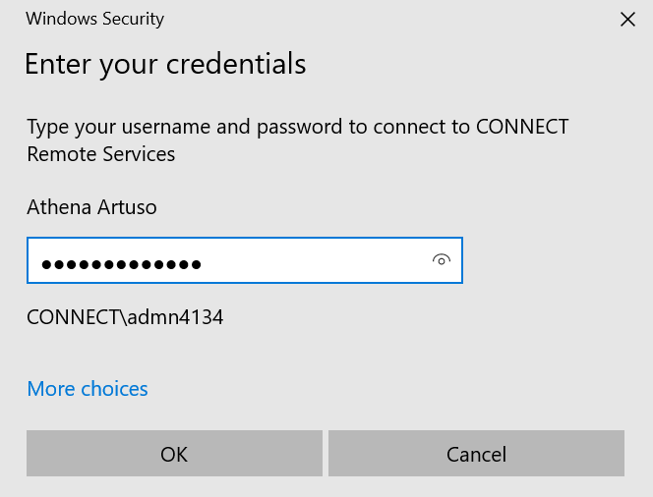

After a short wait, the splash screen will appear, followed by a sign-in window. Click the “Not now, maybe later” link at the bottom of the sign-in window:

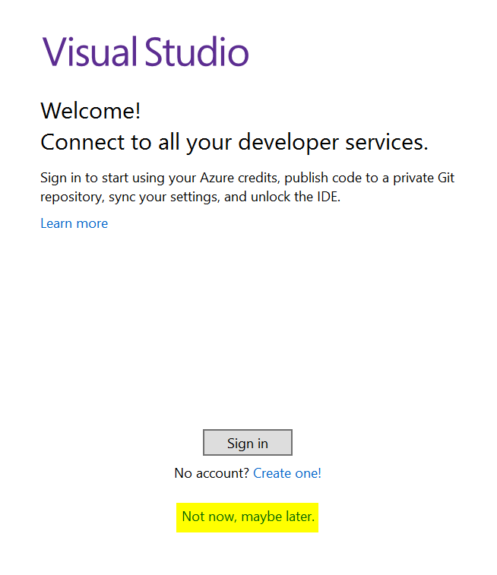

You’ll then be asked for your display preferences. Select Development Settings: General and click Start Visual Studio to complete the app launch.

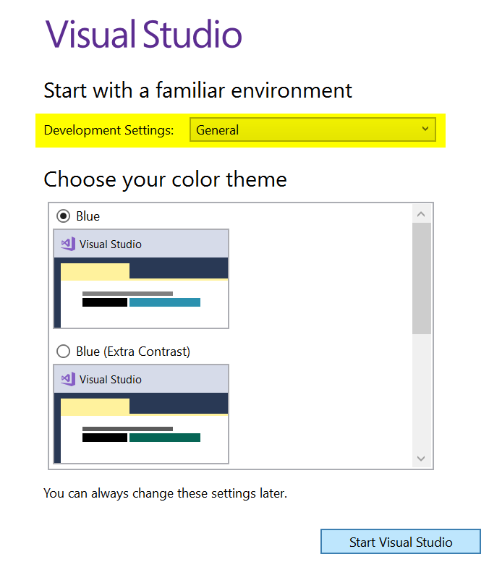

After a short wait (occasionally as long as a minute or two), Visual Studio will open and you will see the Home screen:

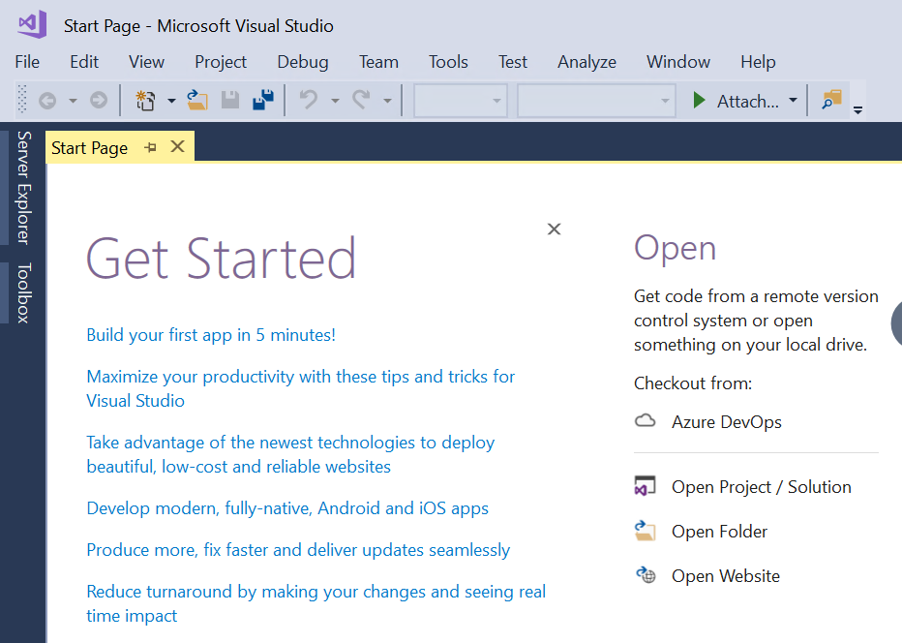

Opening a solution file (.SLN)
Report files in Visual Studio are grouped into larger files called “solutions” (file extension .sln). Each solution has its own data sources, datasets, and report files. There are four solutions for you to choose from in Visual Studio:

Solution | Data source | Notes
HR Reporting DEV | Non-production (generally UOXC) | This is a sandpit environment for creating new reports.
HR Reporting TEST | Non-production (generally UOXU) | This is a test environment, mainly for use by project teams
HR Reporting QA | Production | This is the UAT environment, where reports are deployed for testing by end-users. It is also where old versions of reports are archived.
HR Reporting LIVE | Production | This is the live environment, where final, approved drafts of reports are stored and published to the live server.

Which solution you open will depend on what you need to do in Visual Studio.

To open a solution, go to File > Open > Project / Solution:

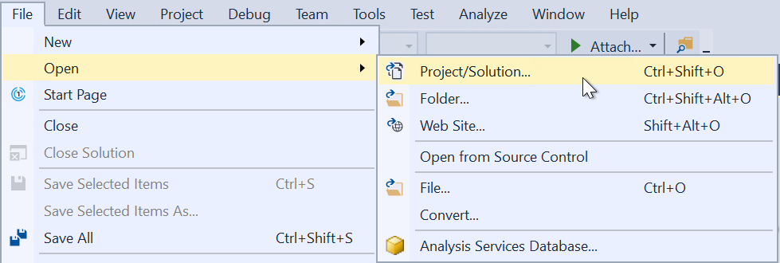

A warning message will appear; just click OK to dismiss it (there is no way to prevent this pop-up, but it has no impact on your ability to use Visual Studio):

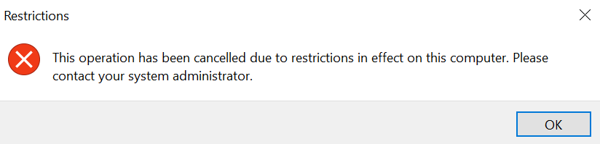

The Open Project file browser will open. You need to navigate to I:\OUIT\CoreHR Reports. This is a secure network drive owned by Microsoft Platform Services and used for storing all HR Reporting files:

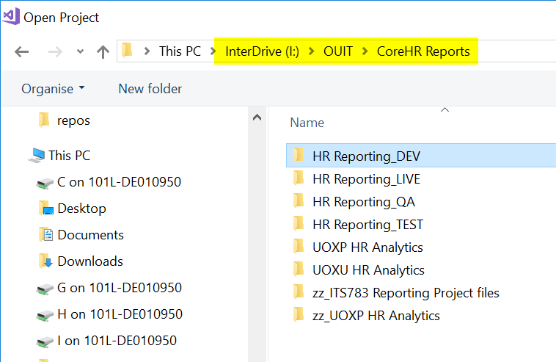

Choose the solution you wish to work in, and double-click the corresponding folder icon. Within the folder, select the solution file and double-click to open:

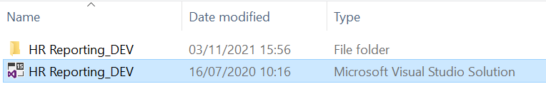

Another warning message will pop up; simply click OK to dismiss it:

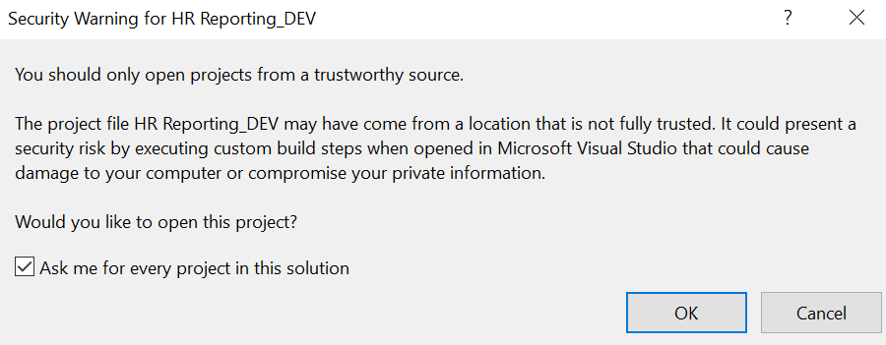

As with the previous pop-up, there is no way to prevent this message from appearing every time you use Visual Studio, but it won’t impact your ability to use the application.

After a moment, the solution file will load. You can always check which solution you have open by looking at the title bar or within the Solution Explorer pane:

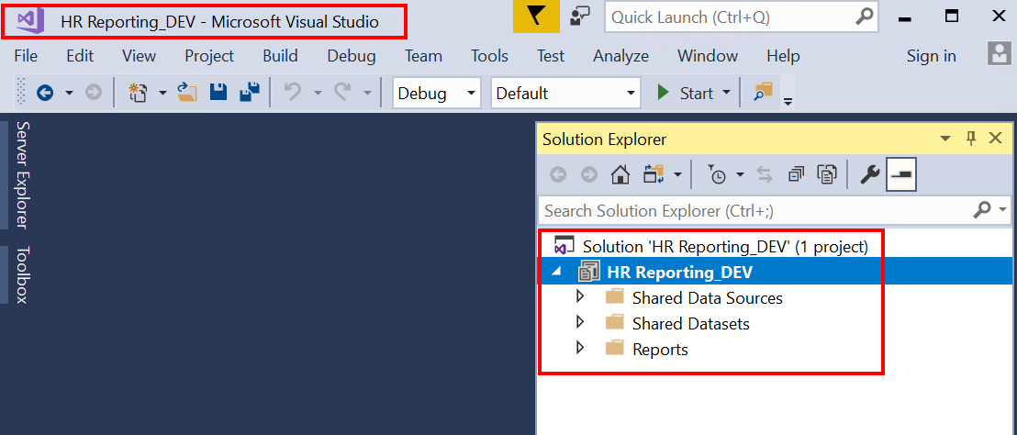

Once you’ve opened a solution, you can open any of the files contained within it. These include:

- Shared data sources
- Shared datasets
- Reports

To open any of these files, go to the Solution Explorer pane on the right side of the screen and expand the folder which contains the file(s) in which you are interested. Double-click the file to open it.

 | NB: It is not possible to have more than one solution file open at a time. If you want to do some work in HR Reporting DEV and HR Reporting QA, for example, you will need to exit one solution before you can open the other.

Viewing a report file (.RDL)

Open the .RDL
To open a report file, go to the Solution Explorer pane and expand the Reports folder. You will be presented with a list of all the report files currently available to open within the solution.

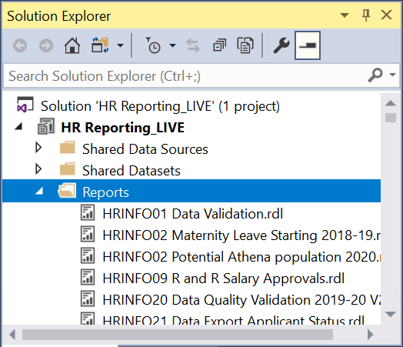

To open one, you can either double-click it, or right-click and select Open from the menu:

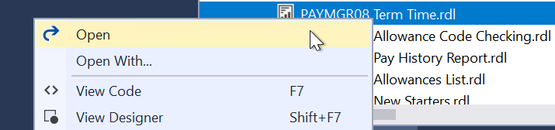

The .RDL file will load and the Design pane will be displayed:

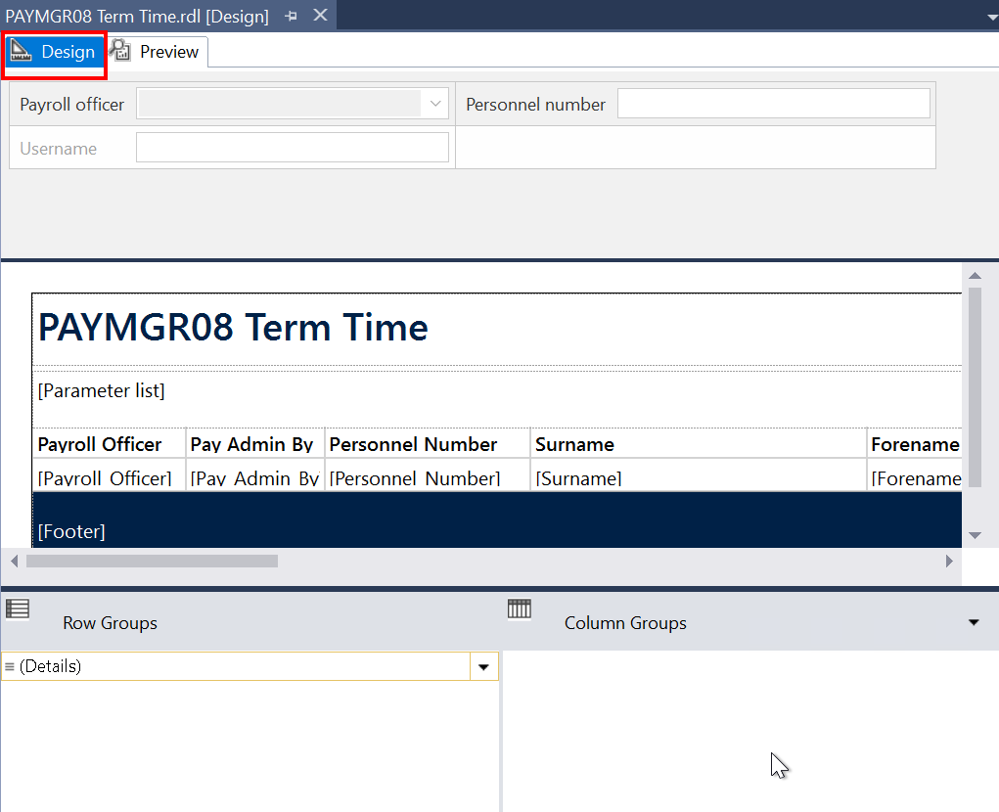

The Design pane
All .RDL files within Visual Studio have a Design pane, where you can format the data from your SQL query into a user-friendly report. The Design pane for every report in the HR Reporting catalogue must contain the following elements:

Title textbox
This textbox appears at the top of the report and contains the title of the .RDL file, in the format [Report prefix] + [.RDL name], e.g. PERDEP01 Limited Data Set.

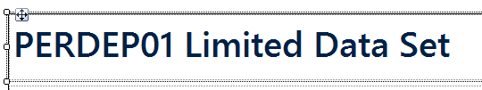

Parameters textbox
This textbox appears underneath the Title, and contains a VBA expression which will display the parameters selected each time the report is run. In the Design pane, it looks like this:

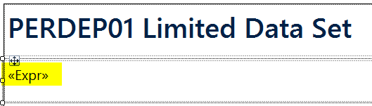

When a report has been run, the Parameters textbox looks like this:

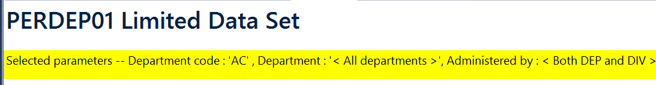

 | NB: Full details on how to edit the VBA expression used in the Parameters textbox are provided in the HOW TO guide (link required).

Report Tablix
The “Tablix” (a Microsoft term) displays report data from a data set in cells that are organized into rows and columns. This is where your report fields are arranged and formatted, and where your results appear when you run the report query. A Tablix can be formatted as a simple table or as a matrix.

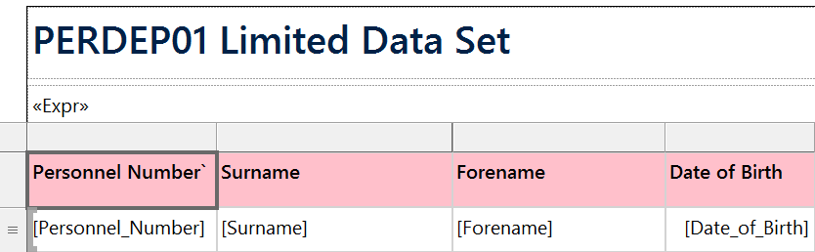

Footer textbox
This textbox appears at the bottom of the screen, and contains a standard VBA expression which will display a message whenever the report is run. The message states the name of the .RDL file, the SSO of the username who ran the report, as well as the date and time of the report run. In the Design pane, it looks like this:

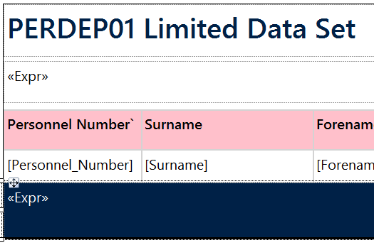

When a report has been run, the Footer textbox looks like this:

 | NB: Do not edit the VBA expression for the Footer textbox; the message displayed must remain standard across the entire HR Reporting catalogue.

The Preview pane
All .RDL files within Visual Studio also have a Preview pane, where you can run your report query and check your results and your formatting without needing to deploy the report to the HR Reporting environments.

To open the Preview pane, simply click the tab at the top of the .RDL file. If your report has parameters, you will be prompted to fill them in, exactly as a report user would be on the HR Reporting environments:

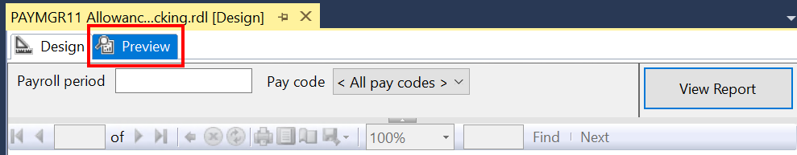

Enter the parameters you wish to use (or none if you don’t want to restrict your results), and click View Report to run the report query. The SQL code of your report will query the PeopleXD database to which your solution is connected, and the “Loading…” message will display while the query runs:

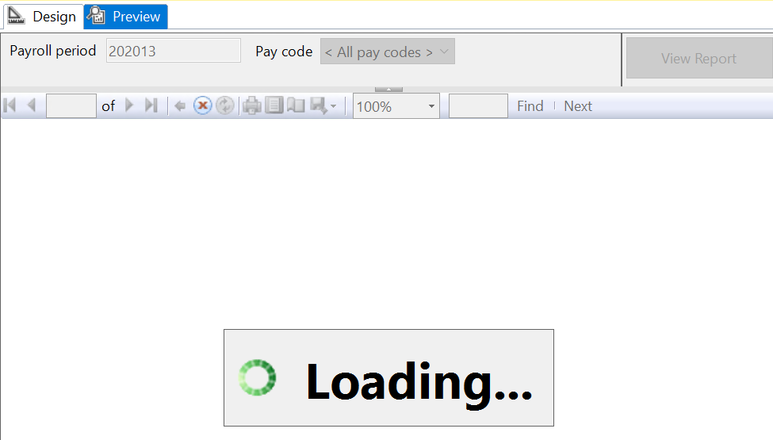

When the query is complete, the report results will load in the Preview pane. The page numbers at the top of the report indicate how many pages of results have been retrieved.

 | NB: The parameter prompts at the top of the screen can be edited if you want to re-run the report with new parameters – simply change the parameter values and click View Report to re-run your query.

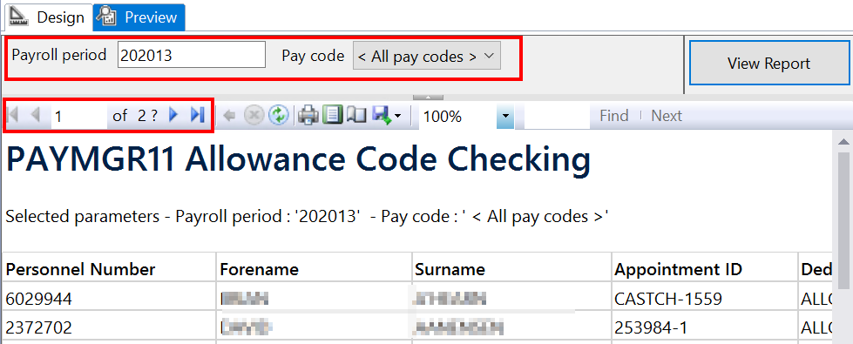

You can export your results by clicking the Save icon and choosing the export file format:

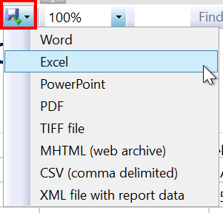

To exit the Preview pane, simply click back into the Design tab at the top of the .RDL file.

The Report Data pane
The Report Data pane is where you configure the individual elements of your .RDL file: its data sources, datasets, and parameters. The Report Data pane is located on the left side of the screen:

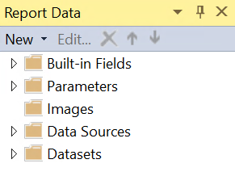

Expand any of the folders to view their contents. A brief description of each is given below.

 | NB: The Built-in Fields are essential components of all .RDL files, and are included as standard in every report. We don’t ever edit these values. We also don’t use the Images functionality within Visual Studio, so this folder can be ignored.

Parameters
The Parameters folder lists each parameter present in your report.

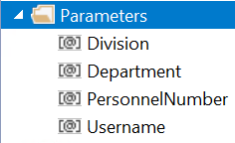

A parameter must exist in multiple locations within every .RDL file:

- The SQL code of your report query: essential
- The Parameters folder of the Report Data pane: essential
- The Parameters textbox: optional (if you want the parameter values displayed on the report each time it is run)

You can add new parameters to the Report Data pane by right-clicking the Parameters folder and selecting Add Parameter….

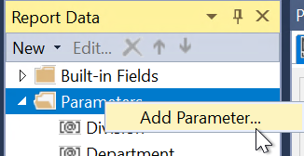

 | NB: Never add a parameter within the Report Data pane without also adding it to the SQL code of your query. Parameters must exist within your SQL code or they will not work!

You can click into each parameter to view or edit its properties. Double-clicking a parameter will open the Report Parameter Properties window for that specific parameter.

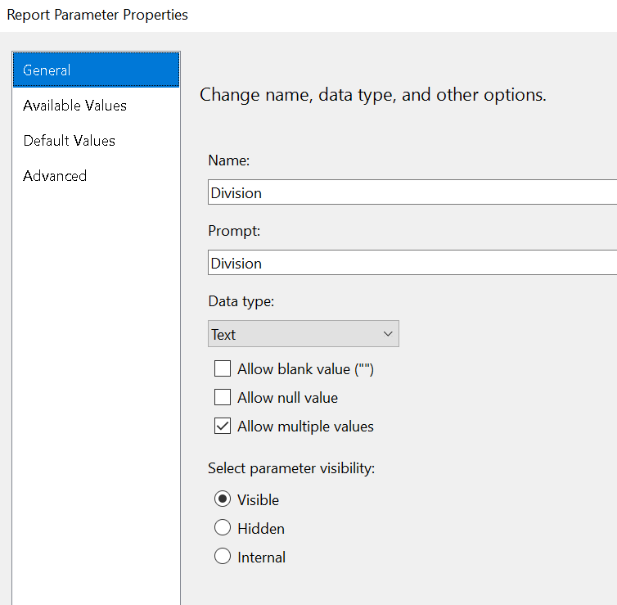

There are three main sections to any parameter which you must configure.

General
The General properties of a parameter include:

Property | Values | Notes
Name | Name of the parameter | This must exactly match the name of the parameter within the report SQL code; e.g. if your parameter is called PersonRef within the SQL code, it must be called PersonRef within the properties screen.
Prompt | The user prompt | This can be whatever you like (although there are naming standards); e.g. the PersonRef parameter can have the prompt value of “Personnel number”.
Data type | Text, Boolean, Date/Time, Integer, Float | The only values used within HR Reporting .RDL files are Text (for alphanumeric fields) and Date/Time for date parameters.
Visibility | Visible, Hidden, Internal | All parameters are Visible by default, except the Username parameter, which is Hidden.

Available Values
If your parameter is powered by a drop-down list of values (LOV), you can either define the LOV here or select a shared dataset from which to derive the values.

Default Values
If you want a default value for your parameter, you can define it here.

Data Sources
The Data Sources folder lists each data source present in your report. All reports must contain the two standard shared data sources:

- Oracle_DS_ServiceAccount: the service account is used to run the queries for shared datasets, e.g. to retrieve all department codes for use in a parameter’s drop-down list.
- Oracle_DS_UserCredentials: the user account is used to run the main report SQL code – it’s each report user’s individual reporting login credentials. By passing these credentials to PeopleXD, the database can automatically detect and apply the correct security when retrieving report results; e.g. a user who is only allowed to see Pay Group 20 will only see results for Pay Group 20.

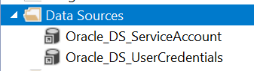

If you are missing either data source (for instance, if you are creating a new report), simply right-click the Data Sources folder and select Add Data Source….

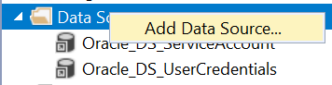

Datasets
The Datasets folder lists each dataset present in your .RDL file. This includes the main report query, as well as any additional datasets which are used to power your parameters.

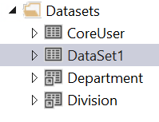

 | NB: The main report query should always be named “DataSet1”, while any parameter-related datasets should have descriptive names linking them to their parameters, e.g. Department for a dataset which provides a list of departments for the Department parameter.
Double-click any dataset to open the Dataset Properties window.

If you are looking at an embedded dataset, you can view the raw SQL code of the dataset in the Query pane:

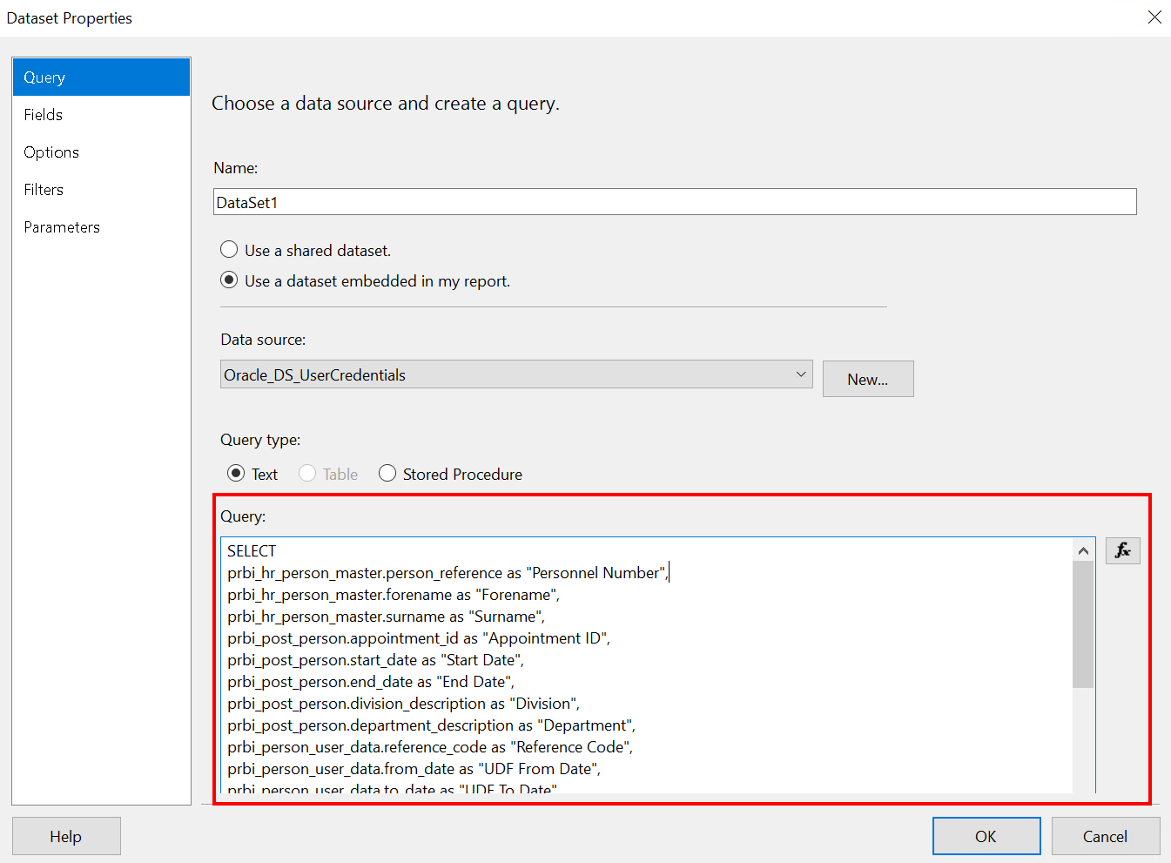

If you are looking at a shared dataset, you will be able to see the full name of the shared dataset – this will enable you to select the shared dataset from the Solution Explorer pane to view the SQL code for that dataset.

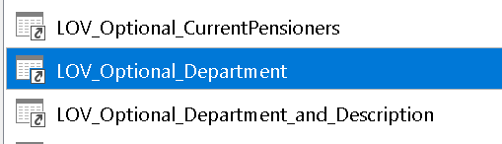

Viewing a shared dataset (.RSD)
To open a shared dataset, go to the Solution Explorer pane and expand the Shared Datasets folder. You will be presented with a list of all the shared dataset files currently available to open within the solution.

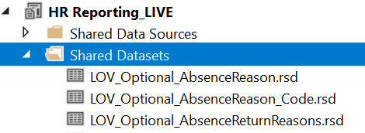

To open one, you can either double-click it, or right-click and select Open from the menu:

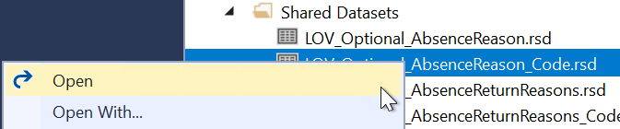

The Shared Dataset Properties window will open and the Query screen will be displayed. The Query screen holds the SQL code for the dataset, enabling you to see what information the dataset is retrieving from PeopleXD.

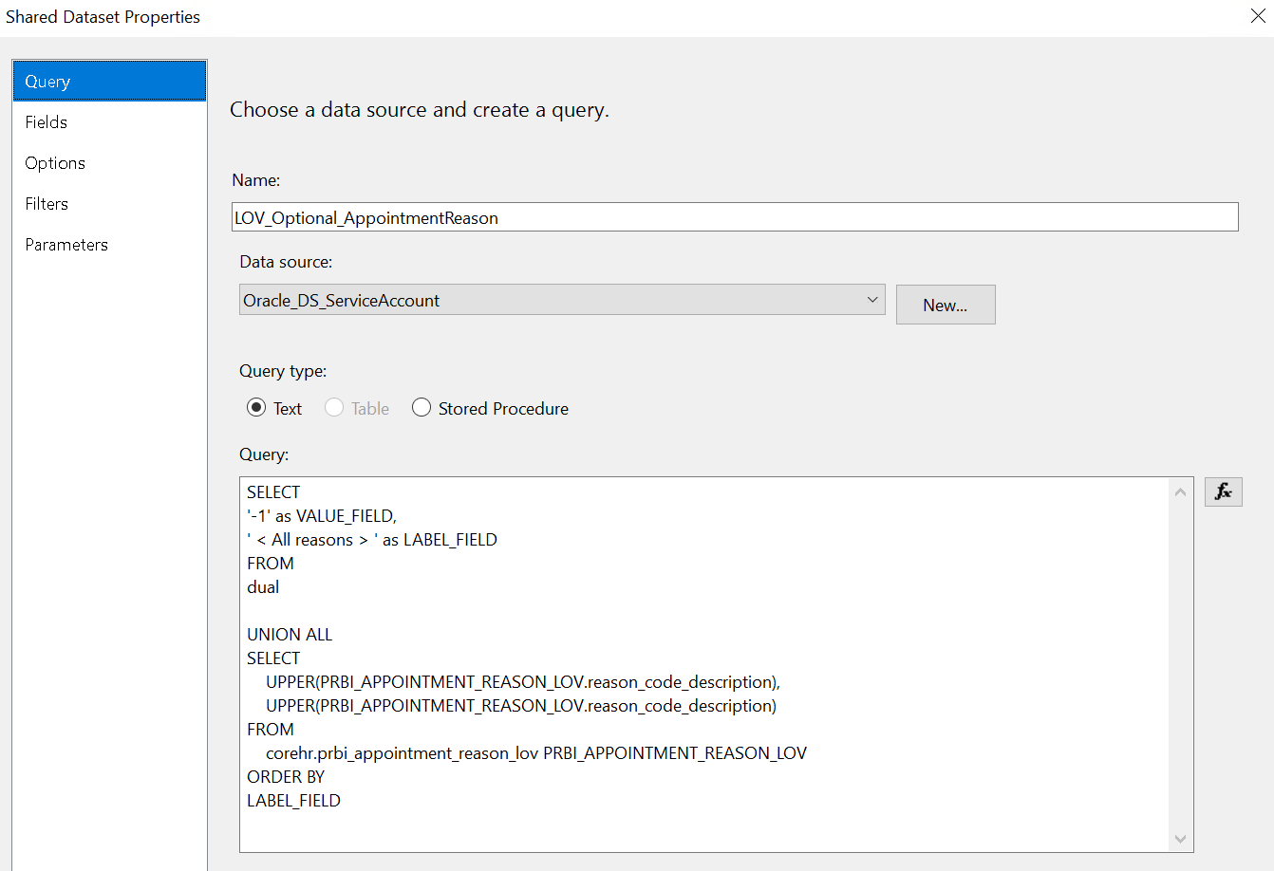

 | NB: Never amend a shared dataset without speaking to Athena Artuso. Shared datasets are used by multiple reports across the HR Reporting catalogue, and any changes to a shared dataset will impact all its dependent reports.

Viewing a shared data source

Open the data source
To open a shared data source, go to the Solution Explorer pane and expand the Shared Data Sources folder. You will be presented with a list of all the shared data sources currently available to open within the solution.

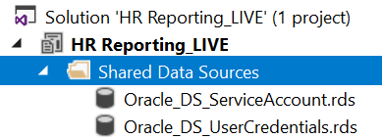

To open one, you can either double-click it, or right-click and select Open from the menu:

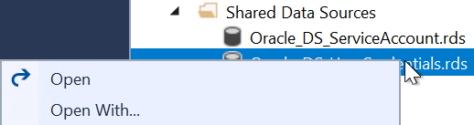

The Shared Data Source Properties window will open and the General screen will be displayed. The Connection String field will show you which PeopleXD database the current Visual Studio solution is connected to:

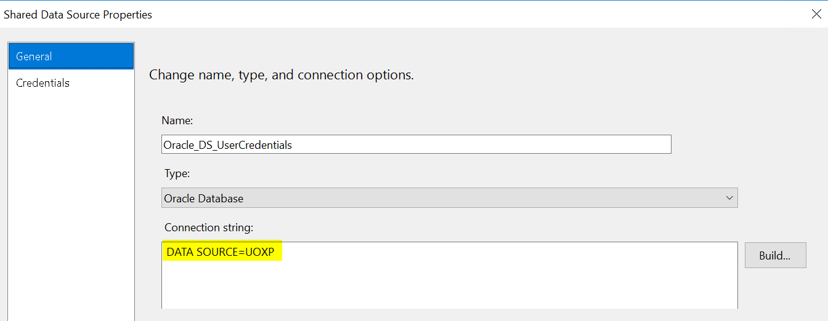

 | NB: Do not change the Connection String for a shared data source without first speaking to Athena Artuso or Simon Burford.  Never update the Connection String in the HR Reporting LIVE solution; this must always be connected to UOXP.

View the connection credentials
Each data source connects to PeopleXD by logging into the PeopleXD database specified in the Connection String. This means that login credentials must be supplied to the data source.

To check the login credentials on any data source, click Build… next to the Connection String field:

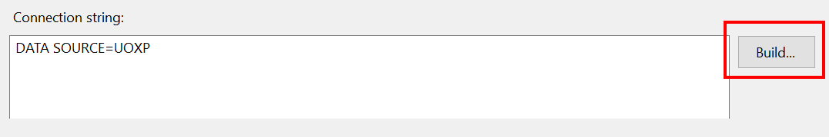

The Connection Properties window will pop up. This window will confirm which PeopleXD database you are using, and will display the login credentials being used to access that database.

UserCredentials data source
For the Oracle_DS_UserCredentials data source, the login credentials can be set to your personal reporting login details – this will enable you to run your report in the Preview pane without having to provide your username and password every time you way to run your query. Just enter your login details in the Connection Properties window and select “Save my password” to store your password for the duration of your Visual Studio session. If you want to check that you’re able to log into the PeopleXD database, click Test Connection:

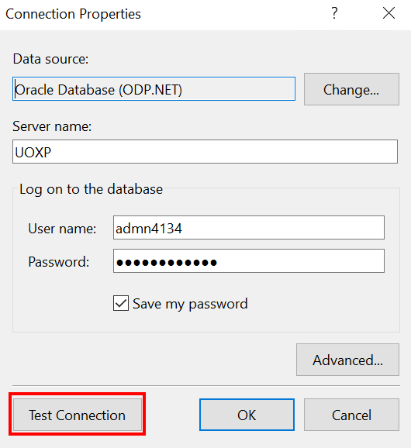

Visual Studio will check your credentials and confirm whether the database is accessible:

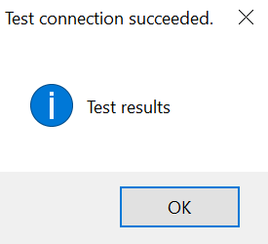

ServiceAccount data source
For the Oracle_DS_ServiceAccount data source, the login credentials are the same across all environments. Click Build… to view the login credentials and click Test Connection to ping the PeopleXD database and confirm whether it is accessible.

 | NB: The Service Account has unlimited user sessions and unrestricted access to PeopleXD’s databases, so it must be kept highly secure to prevent unwanted data breaches. Only a subset of reporting super-users (Athena Artuso and Simon Burford) know the login credentials for the Service Account data source, and they must periodically update these login credentials to keep the account secure.  The Service Account username is REPORT_POWERBI. This is static across all HR Reporting environments and must never be changed.

Deploying files to HR Reporting servers
If you want to make a Visual Studio file available on one of the HR Reporting servers, you must deploy that file to the server in question. You can deploy:

- Shared data sources
- Shared datasets
- Report (.RDL) files

The name of the solution file within Visual Studio confirms which HR Reporting server your files will be deployed to, e.g. if you are using HR Reporting DEV.sln, any files you deploy from Visual Studio will be published to the HR Reporting DEV environment.

 | NB: There is a 1-to-1 relationship between a Visual Studio solution and its corresponding HR Reporting server; this is defined at the solution level and applies to all files within that solution.  - HR Reporting DEV.sln deploys to HR Reporting DEV  - HR Reporting TEST.sln deploys to HR Reporting TEST  - HR Reporting QA.sln deploys to HR Reporting QA  - HR Reporting LIVE.sln deploys to HR Reporting LIVE

To deploy a file, select it in the Solution Explorer pane and right-click. Select Deploy from the right-click menu:

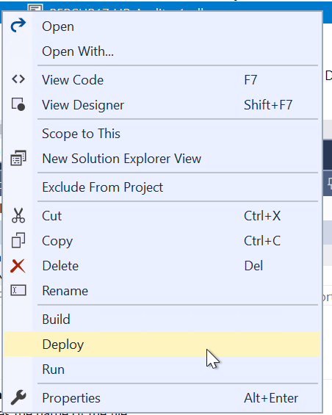
The deployment progress will display in the Output pane at the bottom of your screen. Look at the final message to see whether your deployment has succeeded or failed:

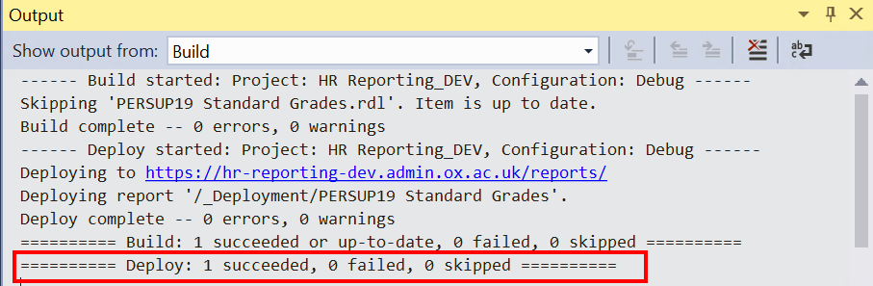

If your deployment has succeeded, the file will be available on the relevant HR Reporting server. If your deployment has failed, you will see an Error List pane with a description of the reason for the failure:

